**BANK LOAN REPORT QUERY DOCUMENT**

**BANK LOAN REPORT | SUMMARY**

**KPI’s:**

**/*Total Loan applications*/**

**select count(id) as `Total Loan applications` from `financial_loan`;**



**/*Month to date Loan Application*/**

**select count(id) as `MTD Loan Application` from `financial_loan` where month(issue_date) = 12 and year(issue_date) = 2021;**



**/*Previous Month Loan Application*/**

**select count(id) as `MTD Loan Application` from `financial_loan` where month(issue_date) = 11 and year(issue_date) = 2021;**



**/*Total funded amount*/**

**select sum(loan_amount) as `Total funded amount` from financial_loan;**



**/*Month to date Total funded amount*/**

**select sum(loan_amount) as `Month to date total funded amount` from `financial_loan` where month(issue_date) = 12 and year(issue_date) = 2021;**



**/*Previous month total funded amount*/**

**select sum(loan_amount) as `Previous month Total funded amount` from `financial_loan` where month(issue_date) = 11 and year(issue_date) = 2021;**



**/*Total amount received*/**

**select sum(total_payment) as `Total amount received` from `financial_loan`;**



**/*Month to date Total amount received*/**

**select sum(total_payment) as `Month to date total amount received` from `financial_loan` where month(issue_date) = 12 and year(issue_date) = 2021;**

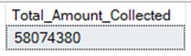

**/*Previous month total amount received*/**

**select sum(total_payment) as `Previous month Total amount received` from `financial_loan` where month(issue_date) = 11 and year(issue_date) = 2021;**



**/*Average Interest Rate*/**

**select concat(round(avg(int_rate),2) * 100,'%') as `Average Interest Rate` from financial_loan;**



**/*Month to date Average Interest Rate*/**

**select concat(round(avg(int_rate),4)*100,'%') as `Month to date Average Interest Rate` from `financial_loan` where month(issue_date) = 12 and year(issue_date) = 2021;**



**/*Previous month Average Interest Rate*/**

**select concat(round(avg(int_rate),4)*100,'%') as `Previous month Average Interest Rate` from `financial_loan` where month(issue_date) = 11 and year(issue_date) = 2021;**



**/*Average dti*/**

**select concat(round(avg(dti),4)*100,'%') as `Average dti` from financial_loan;**



**/*Month to date dti*/**

**select concat(round(avg(dti),4)*100,'%') as `Month to date dti` from `financial_loan` where month(issue_date) = 12 and year(issue_date) = 2021;**



**/*Previous month dti*/**

**select concat(round(avg(dti),4)*100,'%') as `Previous month dti` from `financial_loan` where month(issue_date) = 11 and year(issue_date) = 2021;**



**GOOD LOAN ISSUED**

**/*Good loan percentage*/**

**SELECT**

**concat((COUNT(CASE WHEN loan_status = 'Fully Paid' OR loan_status = 'Current' THEN id END) * 100.0) /**

**COUNT(id),'%') AS Good_Loan_Percentage FROM financial_loan**



**/*Good Loan Applications*/**

**select count(*) as `Good Loan Applications` from financial_loan where loan_status = 'Fully Paid' OR loan_status = 'Current';**



**/*Good Loan Funded Amount*/**

**select sum(loan_amount) as `Good Loan Funded Amount` from financial_loan where loan_status = 'Fully Paid' OR loan_status = 'Current';**



**/*Good Loan Amount Received*/**

**select sum(total_payment) as `Good Loan Amount Received` from financial_loan where loan_status = 'Fully Paid' OR loan_status = 'Current';**



**BAD LOAN ISSUED**

**/*Bad Loan Percentage*/**

**SELECT concat((COUNT(CASE WHEN loan_status ='Charged off' THEN id END) * 100.0) / COUNT(id),'%') AS Bad_Loan_Percentage FROM financial_loan;**



**/*Bad Loan Applications*/**

**select count(*) as `Bad Loan Applications` from financial_loan where loan_status = 'Charged off';**



**/*Bad Loan Amount Received*/**

**select sum(total_payment) as `Bad Loan Amount Received` from financial_loan where loan_status = 'Charged off';**



**/*Bad Loan Funded Amount*/**

**select sum(loan_amount) as `Bad Loan Funded Amount` from financial_loan where loan_status = 'Charged off';**



**LOAN STATUS**

**/*Loan Status*/**

**select**

**loan_status, count(*) as `Application status`, sum(total_payment) as `Total Amount Received`, sum(loan_amount) as `Total Amount funded`,**

**concat(round(avg(int_rate*100),2),'%') as `Interest rate`, concat(round(avg(dti*100),2),'%') as `DTI`**

**from financial_loan**

**group by loan_status**

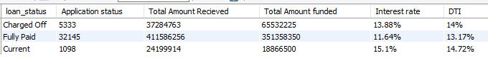

**/*Loan Status by month*/**

**SELECT loan_status, SUM(total_payment) AS 'Month to date Total amount received', SUM(loan_amount) AS 'Month to date Total amount funded' FROM financial_loan WHERE MONTH(issue_date) = 12 GROUP BY loan_status;**

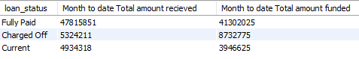

**BANK LOAN REPORT | OVERVIEW**

**/*Bank Loan report by month*/**

**Select monthname(issue_date) as `Month Name`, count(*) as `Total loan Application`, sum(loan_amount) as `Total amount funded`, SUM(total_payment) AS `Total amount recieved`, round(sum(dti),2) as `DTI`**

**from financial_loan**

**group by `Month Name`,month(issue_date)**

**order by month(issue_date)**

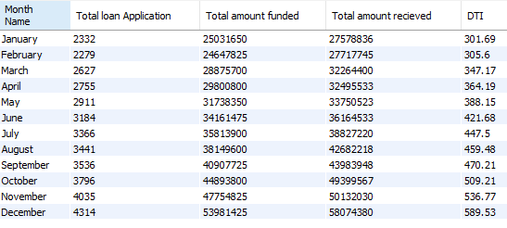

**/* analysis by STATE*/**

**select address_state, count(*) as `Total loan Application`, sum(loan_amount) as `Total amount funded`,**

**SUM(total_payment) AS `Total amount recieved`, round(sum(dti),2) as `DTI`**

**from financial_loan**

**group by address_state**

**order by address_state;**

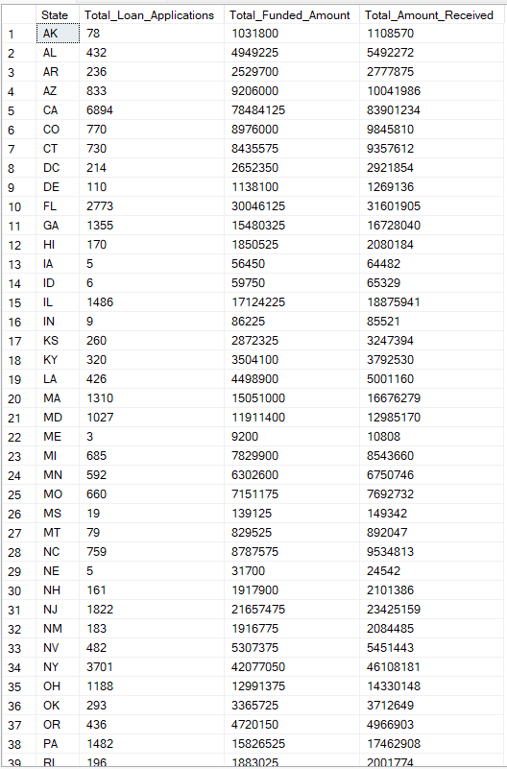

**/*analysis by Term*/**

**select term, count(*) as `Total loan Application`, sum(loan_amount) as `Total amount funded`,**

**SUM(total_payment) AS `Total amount recieved`, round(sum(dti),2) as `DTI`**

**from financial_loan**

**group by term**

**order by term;**

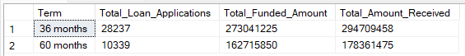

**/*analysis by Employee length*/**

**select emp_length as `Employee length`, count(*) as `Total loan Application`, sum(loan_amount) as `Total amount funded`, SUM(total_payment) AS `Total amount recieved`, round(sum(dti),2) as `DTI`**

**from financial_loan**

**group by emp_length**

**order by emp_length;**

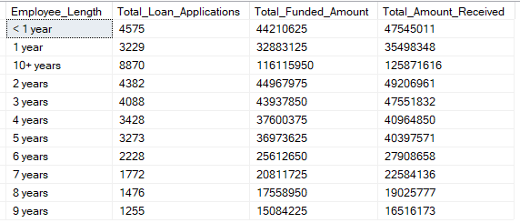

**/*analysis by purpose*/**

**select purpose , count(*) as `Total loan Application`, sum(loan_amount) as `Total amount funded`,**

**SUM(total_payment) AS `Total amount recieved`, round(sum(dti),2) as `DTI`**

**from financial_loan**

**group by purpose**

**order by purpose;**

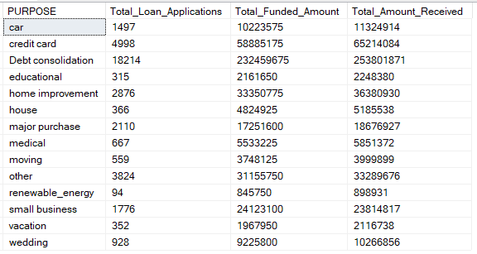

**/*analysis by Home Ownership*/**

**select home_ownership , count(*) as `Total loan Application`, sum(loan_amount) as `Total amount funded`,**

**SUM(total_payment) AS `Total amount recieved`, round(sum(dti),2) as `DTI`**

**from financial_loan**

**group by home_ownership**

**order by home_ownership;**

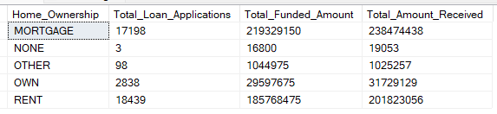

**/*Which term gets the highest installments*/**

**select term, count(*) as `Total loan Application`, sum(loan_amount) as `Total amount funded`, SUM(total_payment) AS `Total amount recieved`,**

**round(sum(dti),2) as `DTI`, round(sum(installment),2) as `installment`**

**from financial_loan**

**group by term**

**order by term;**



**/*Amount disbursed and recieved based on verfication status*/**

**select verification_status, count(*) as `Total loan Application`, sum(loan_amount) as `Total amount funded`, SUM(total_payment) AS `Total amount recieved`,**

**round(sum(dti),2) as `DTI`**

**from financial_loan**

**group by verification_status**

**order by verification_status;**

